Big Mountain Resort - Project Report

**The Problem**: Big Mountain Resort is a ski resort in Montana that recently added a new chair lift increasing their overall operation costs by $1,540,000 each season. Our aim in this analysis is to recommend a strategy by the start of this next ski season allowing Big Mountain Resort to avoid net loss each season by increasing ticket prices to up revenue by at least $1,540,000 each season.

Currently, Big Mountain Resort charges $81 per ticket, serving an average of 350,000 customers each season, each customer purchasing an average of 5 tickets. We use ticket price as a response to gather if and how Big Mountain can adjust their price.

**The Data**: Our main dataset includes general information on all resorts throughout the United States. This includes: region, terrain, transportation, area and number of runs (day and night), amount of artificial snow, number of days open, and price of ticket information. We also have a dataset for each state: the total area, population, skiable area, total resorts, total ski days open, and total night ski resorts. Combining these datasets we calculate ratios that give insight to the impact a resort has within its specific state. Note: Since 'AdultWeekday' prices are missing more often than 'AdultWeekend' prices, we decide to use the 'AdultWeekend’' price as a response variable in our analysis. As seen below, the Adult Weekend and Adult Weekday prices are generally very similar.

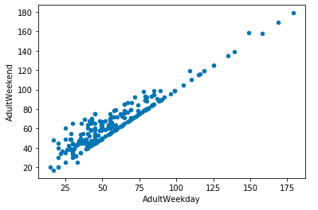

**Exploratory Analysis**: Some key relationships to note are the increase in weekend ticket price when it comes to: vertical drop, number of runs, and total number of chairs. Each chart below shows the increasing trend respectively.

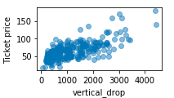 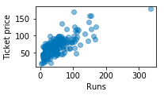

**Model Preprocessing:** We initially pose the question: why not use the average ticket price of about $63 as a prediction? From this we find an mean absolute error (MAE) of about 19 which tells us that using the average, we expect to be off by about $19.

To improve this, we look at a simple linear regression which provides a prediction off by about $9 (MAE of 9.4) and confidence that about 72% of our variance is being explained beyond using the mean alone (r^2 of .72). This is good, but we can do better.

Up to this point, we have fit all variables in our dataset as predictors. We perform a gridsearch to find the optimal number of parameters in the linear regression, we find 8 variables to be best as it provides less variance and less overfitting. These variables are : Vertical Drop, Snow Making, Total Chairs, Fast Quads, Runs, Longest Run, Trams, and Skiable Terrain. These match up to the relationships we saw in the ‘Exploratory Analysis.’

As an additional process, we use Random Forest Regression. We find 4 features to be most important in this model: Fast Quads, Runs, Snow Making, and Vertical Drop. These are also in the top 8 variables from the simple linear regression.

Comparing the final linear regression to our final random forest model we find a MAE of 11.79 and 9.49 respectively. We move forward with the Random Forest Regression for the final model.

**Model Results**: Big Mountain Resort currently charges $81 per ticket, our model suggests that the price should be set at about $94 per ticket, a $13 increase.

Compared to other resorts around the country, Big Mountain Resort is well above the median in its vertical drop, amount of snow making, and total number of runs.

See charts below:

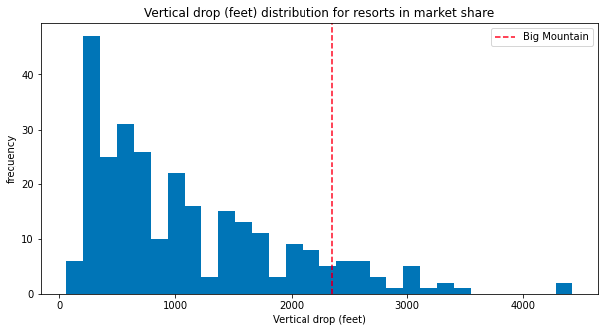 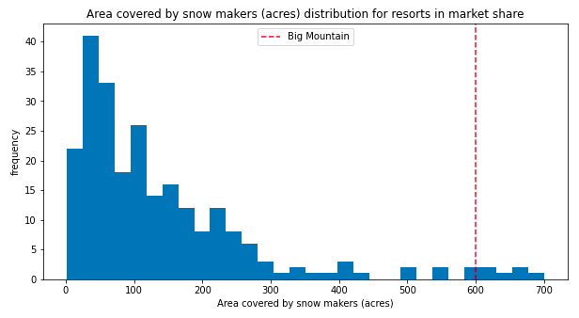 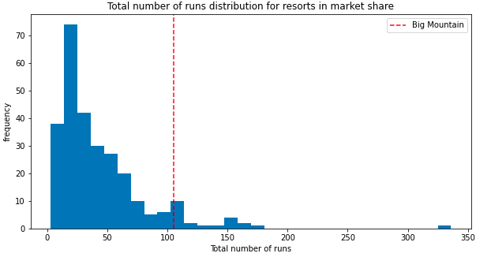

**Current Recommendation**: As these are 3 of the 8 most important features according to our model training, we have reason for Big Mountain Resort to increase their price. We recommend Big Mountain Resort to up their price by $13. With an average of 350,000 visitors purchasing an average of 5 tickets each season, this increase in ticket price would increase revenue by $22,750,000 well above the 1,540,000 dollars needed for the new chair lift.

**Future Improvements:** For additional revenue, we figure Big Mountain Resort has a few options 1. Permanently close down up to 10 of the least used runs. 2. Increase the vertical drop by adding a run to a point 150 feet lower down requiring the installation of an additional chair lift to bring skiers back up, without additional snow making coverage. 3. Same as number 2, but adding 2 acres of snow making cover 4. Increase the longest run by 0.2 mile to boast 3.5 miles length, requiring an additional snow making coverage of 4 acres.

Our model suggests that the best option would be Option 2, adding a run to a point 150 feet lower and installing an additional chair lift to bring skiers back up. This provides reason to increase ticket price by $1.99; assuming the average 350,000 customers spend and average of 5 days at the resort, Big Mountain's revenue would increase by $3,474,638.